**Assessment 3**

**(Operators & Conditions)**

**Email address:**

**Write your name:**

**1.** Which one of the following if statements will not execute successfully: (3 Points)

* Code 1

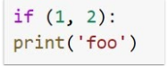

* Code 2

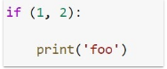

* Code 3



* Code 4

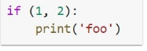

**2.** In a Python program, a control structure: (2 Points)

* Defines program-specific data structures
* Dictates what happens before the program starts and after it terminates
* Manages the input and output of control characters
* Directs the order of execution of the statements in the program

**3.** What signifies the end of a statement block or suite in Python?

(2 Points)

* end
* A line that is indented less than the previous line
* A comment
* }

**4.** Given the nested if-else structure below, what will be the value of x after code execution completes- (3 Points)

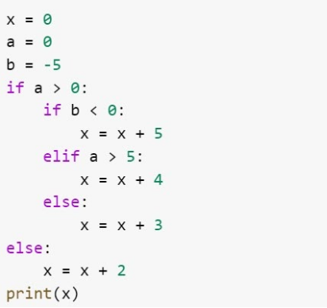

* 2
* 0
* 3
* 4